Date:16/3/2023

Accounting and financial analytics with Zoho

books Assignment -3.

Name:S Gunasekhar

**REPORT TITLE**

Analyzing Competitive Advantage in Real Companies

horizontal line

# 

# Introduction

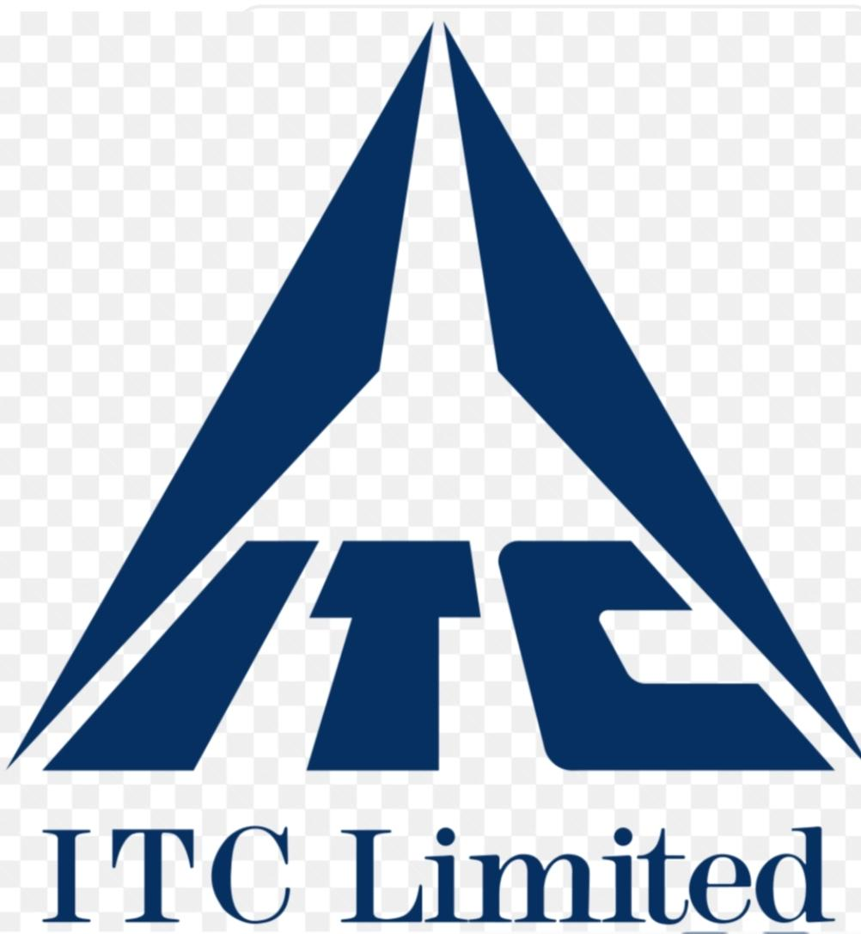

ITC Limited is a British-owned company that has diversified into multiple business areas, including food processing, retailing, financial services, hotels, packaging, paperboards, specialty papers, and agri-business. ITC's Branded Packaged Foods business is one of the fastest growing foods businesses in India, represented in multiple categories, including staples, spices, biscuits, confectionery & gums, snacks, and noodles. Some of ITC's popular brands include:

* Aashirvaad
* Bingo!
* Sunfeast
* Fabelle
* Sunbean
* Yippee!
* Kitchens of India

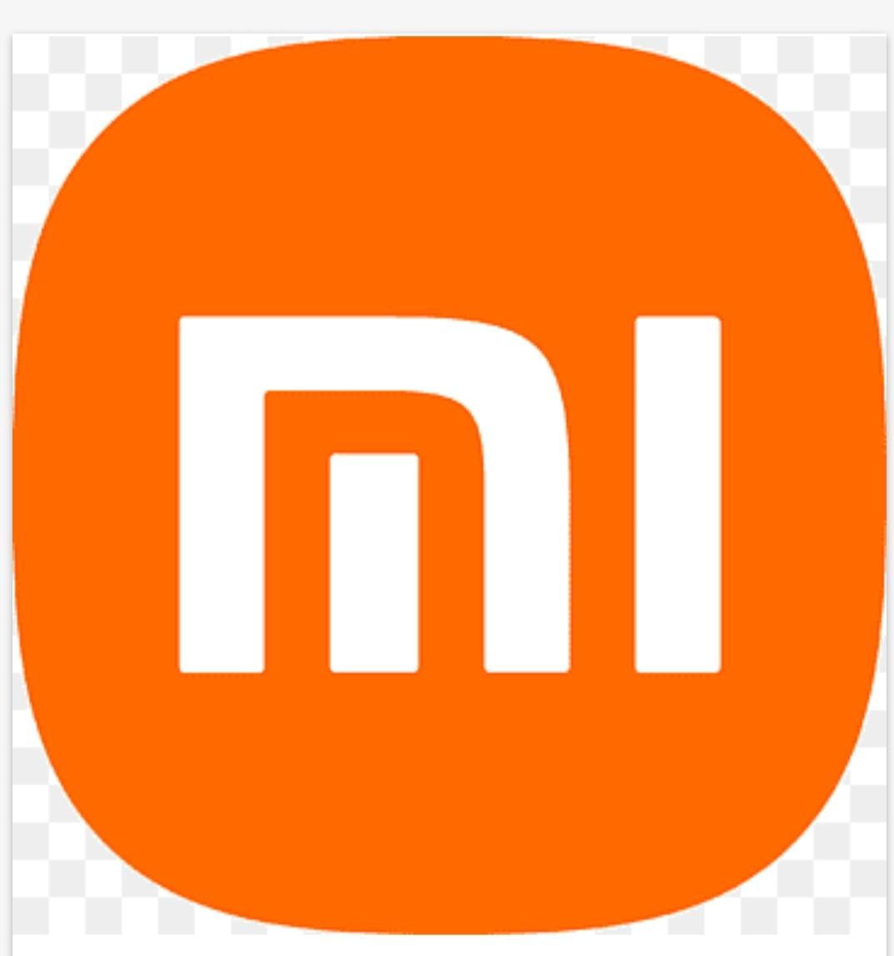

Xiaomi is a Chinese electronics company that entered the Indian smartphone market in 2014, and has become one of the most popular brands in recent years. Xiaomi has gained popularity by offering high-quality smartphones at affordable prices, and has recognized that affordability is a crucial factor in the Indian market.Some of Xiaomi's popular brands include:

* Redmi
* Mi
* Poco

**Background analysis of companies**

## ITC limited

ITC was established in 1910 and has 13 businesses in five segments, including fast moving consumer goods, hotels, paperboards and packaging, agri business, and information technology. ITC has operations across North America, Europe, and South-East Asian countries, and its products are available in 6 million retail outlets and exported to 90 countries.

ITC is one of India's foremost private sector companies with a Gross Revenue of ₹ 69,481 crores and Net Profit of ₹ 18,753.31 crores (as on 31.03.2023) with presence in FMCG, Hotels, Packaging, Paperboards & Specialty Papers, Agri & IT Businesses. Core Values. Corporate Governance.

### Xiaomi

Xiaomi Corporation is a Chinese consumer electronics and smart manufacturing company that was founded in 2010 by Lei Jun. The company is headquartered in Beijing, China and sells products in over 100 countries and regions. Xiaomi is the world's second-largest smartphone manufacturer, behind Samsung, and is known for its budget-friendly phones and advanced feature.

Xiaomi's products include smartphones, smart devices, fitness bands, power banks, headphones, bluetooth devices, protective cases, back covers, smart bands, security cameras, sensors, routers, smart LED bulbs, portable mice, handheld vacuum cleaners, mi electric scooters, and backpacks. The company's core products are smartphones and smart hardware that are connected by an IoT platform.

**Competitive advantages**

**ITC limited**

According to the SWOT analysis conducted on ITC limited it's revealed that The following are the strengths that have helped ITC remain in business for over a century:

**1.Diversified Portfolio**

In the highly competitive business landscape, companies that possess a diversified portfolio enjoy a distinct advantage. ITC has strategically ventured into multiple industries, including fast-moving consumer goods (FMCG), agribusiness, hotels, paperboard, and information technology.

This diversification has proven to be a pillar of strength for the company. ITC Ltd’s diversified portfolio provides a buffer against market fluctuations that may affect individual sectors.

**2.Strong Brand Equity**

Brand equity plays a pivotal role in the success and sustainability of any business. For ITC Ltd, a conglomerate operating in various industries, solid brand equity is undeniably a significant strength. ITC Ltd’s substantial brand equity fosters a high level of consumer trust and loyalty. Through consistent delivery of quality products and services, the company has cultivated a positive reputation among its target audience.

**3.Extensive Distribution Network**

An extensive distribution network is often a critical factor that can propel a company to success. ITC Ltd possesses an extensive distribution network that spans urban and rural areas in India. This enables the company to reach a vast and diverse consumer base.

ITC Ltd’s extensive distribution network also provides a competitive advantage when launching new products or expanding into new markets.

**4.Sustainable Practices**

Companies are increasingly realizing the importance of adopting sustainable practices, as the business landscape changes rapidly. By integrating sustainability into its operations, ITC has shown its deep commitment to environmental stewardship, social responsibility, and ethical governanceIn conclusion, ITC’s sustainable practices not only enhance its brand reputation but also positions the company for long-term success in a rapidly evolving business landscape.

**4.Strong Research and Development (R&D) Capabilities**

ITC stands out for its strong research and development (R&D) capabilities that help it stay ahead of the curve. The company’s R&D capabilities serve as a driving force behind product innovation. The company invests heavily in R&D activities to develop cutting-edge technologies, novel product formulations, and unique solutions that meet evolving customer needs.

Through its strong R&D capabilities, ITC Ltd focuses on enhancing the quality and performance of its products and services. Also, the company invests in patents, trademarks, copyrights, and trade secrets to protect its innovative technologies, processes, and formulations. In conclusion, ITC’s strong R&D capabilities foster market differentiation, nurture collaborative partnerships, and future-proof its business.

**Xiaomi**

According to the SWOT analysis conducted on Xiaomi it's revealed that The following are the key strengths of the company:

**1.Cost-effective Products:** Xiaomi is known for offering feature-rich devices at competitive prices. This value-for-money proposition is a significant strength that has helped the company gain market share, particularly in emerging markets

**2.Wide Product Range:** Xiaomi’s product range is not limited to smartphones. They offer an array of products, from smart TVs to IoT devices, lifestyle products, and more. This diverse portfolio allows them to cater to a broad customer base and creates multiple revenue streams.

**3.Strong Brand Presence:** Xiaomi has developed a strong brand image among younger demographics. The company has a reputation for innovation and delivering high-quality products, which has helped it build a loyal customer base.

**4.Innovative Marketing Strategy:** Xiaomi’s unique marketing strategy, which initially relied heavily on social media and word-of-mouth, helped it create buzz and attract customers without massive advertising expenses. Their flash sales and limited edition models have created a sense of exclusivity and urgency that drives demand.

**5.Focus on User Experience:** Xiaomi’s focus on user experience is another strength. Their MIUI user interface offers a lot of customization options and unique features, which have been well-received by users. They also actively solicit and incorporate user feedback to improve their products and services.

**6.Strong Online and Offline Retail** **Network:**

Xiaomi has a strong online presence and effectively uses e-commerce platforms to sell its products. In addition, they have been steadily building their offline retail network through Mi Home stores and partner outlets, allowing them to reach customers who prefer offline shopping.

**7.Investments in Research and Development**: Xiaomi invests heavily in R&D to drive product innovation and maintain competitiveness. They have made strides in areas like AI, IoT, and 5G technology, keeping them at the forefront of these emerging fields.

**Financial Performance Evaluation**:

**ITC limited**

**ITC Balance Sheet Analysis**

**Asset analysis of fy23**

Current assets rose 16% and stood at Rs 397 billion, while fixed assets rose 7% and stood at Rs 462 billion in FY23. Overall, the total assets and liabilities for FY23 stood at Rs 858 billion as against Rs 772 billion during FY22, thereby witnessing a growth of 11%

**Liability analysis of fy23**

The company's current liabilities during FY23 stood at Rs 137 billion as compared to Rs 122 billion in FY22, thereby witnessing an increase of 13.0%. Long-term debt down at Rs 35 million as compared to Rs 49 million during FY22, a fall of 28.0%.

[Balance sheet report on 22-23](https://ptcul.org/document/ptcul-balance-sheet-fy-2022-23--.pdf)

Financial ratio’s of ITC Ltd

**1.Gross profit margin**

In 2023, ITC's gross profit margin was 57.9%, which is a 4.5% increase from 2022.

**2.working capital**

ITC's current ratio in 2023 was 2.9%, up from 2.8% in 2022. This is the fifth-lowest current ratio in the company's history.

**3.current ratio**

ITC's working capital ratio in 2023 is 0.61, which is higher than the average working capital ratio. This is due to a 152.84% increase in current assets in the fourth quarter of 2023, which is faster than current liabilities

**4.inventory turnover ratio**

ITC's Inventory Turnover for the quarter that ended in Dec. 2023 was 0.47. Days Inventory indicates the number of days of goods in sales that a companyhas in the inventory.

**5. leverage**

ITC Limited's degree of financial leverage (dfl) for fiscal years ending in March 2023 averaged 1.00, with a low of 1.00 in March 2023 and a high of 1.00 in March 2020. This means that ITC has operated at a median dfl of 1.00 from 2019 to 2023.

**6. Return on assets**

ITC Limited's (ITC) return on assets (ROA) for 2023 is 23.89%, which is a 16.3% increase from 2022

**7. Return on equity**

ITC's ROE ratio for March 2023 was 30.07, and for March 2022 it was 25.89

[ITC limited reports and accounts 2023](https://www.itcportal.com/about-itc/shareholder-value/annual-reports/itc-annual-report-2023/pdf/ITC-Report-and-Accounts-2023.pdf)

**Xiaomi**

**Xiaomi Balance Sheet Analysis**

**Asset analysis of fy23**

Short-term assets: 173 billion CNY, which is more than short-term liabilities of 95 billion CNY

Long-term assets: 292 billion CNY, which is more than long-term liabilities of 137 billion CNY

**Liability analysis of fy23**

Xiaomi's total liabilities are $19.77 billion, which includes all current and non-current debts and obligations

[Xiaomi annual report](https://ir.mi.com/system/files-encrypted/nasdaq_kms/assets/2023/04/26/6-55-12/2022%20Annual%20Report_ENG.pdf)

**Financial ratio’s of Xiaomi corp**

**1.Gross profit margin**

As of September 30, 2023, Xiaomi's gross profit margin was 22.72%, which is an increase from 21.0% in the previous quartarly

**2.working capital**

Xiaomi Corp's working capital changed by 22.8B CNY as of June 30, 2023.

**3.current ratio**

Xiaomi's current ratio was 1.81, which is the highest it has been in the last five years.

**4.inventory turnover ratio**

Xiaomi's inventory turnover for the quarter ending in September 2023 was 1.44, or $5,209 million.

**5. Return on assets**

Xiaomi's return on assets hit its 5-year low in December 2022 of 0.9%.

**6. Return on equity**

Xiaomi's annualized return on equity (ROE) for the quarter ending in September 2023 was 12.28%. This is based on the company's net income of $2,671 million for that quarter and an average total stockholders equity of $21,754 million.

[Xiaomi annual report](https://ir.mi.com/system/files-encrypted/nasdaq_kms/assets/2023/04/26/6-55-12/2022%20Annual%20Report_ENG.pdf)

**Comparative Analysis**

**ITC limited**

According to market data, ITC Ltd is India's largest FMCG food manufacturer, surpassing competitors like Adani, Parle, and Britannia. In the nine months ending in September 2023, ITC recorded food FMCG sales of Rs 17,100 crore, which is higher than its competitors:

Britannia: Rs 16,700 crore

Adani Wilmar: Rs 15,900 crore

Parle Products: Rs 14,800 crore

**One of the major competition company to the ITC limited is Hindustan Unilever (Hul) here is comparative analysis conducted by Scholarly articles**

[Scholarly articles for comparative analysis of itc food industry](https://ijritcc.org/index.php/ijritcc/article/download/319/319/294)

**Market share**

ITC has a 12.2% market share in the food FMCG category in India. ITC is India's largest FMCG company in the food sector, and it has introduced more than 100 food FMCG products annually

**Xiaomi corp**

Xiaomi is the second-largest smartphone manufacturer in the world, after Samsung. In 2022, Xiaomi smartphones accounted for almost 13% of the global smartphone market, trailing only Apple and Samsung. Xiaomi's main competitive advantages include its loyalty to its CEO and the brand, as well as its lower prices.

**Here the comparative analysis done by Scholarly articles for comparative analysis of Xiaomi industry**

[Scholarly articles for comparative analysis of Xiaomi industry](https://gvpress.com/journals/IJMUE/vol12_no2/2.pdf)

**Market share**

Xiaomi has a 20.89% market share in India, making it the third most popular smartphone vendor in the country. Xiaomi leads the monthly smartphone market share in India with 20.67%, followed by Vivo with 18.22%, and Samsung with 13.69%.

**Assessment of Sustainability:**

**ITC limited**

The ITC Next strategy for ITC's FMCG Businesses has redefined the critical pathways to growth and profitability by building a future-ready portfolio focused on fortifying and scaling mega brands, leveraging these brands to address value-added adjacencies and crafting categories of the future.

**New Product Launches**

Over the past 3 years, nearly 300 new products were launched, including several premium products, leveraging the innovation capacity of ITC’s Life Sciences & Technology Centre. Some recent examples include: ‘Sunfeast Dark Fantasy’ Desserts, 'Engage L'amante', ‘Classmate Interaktiv’ notebooks and so on. Mega brands are also addressing adjacencies such as ‘Aashirvaad’ range of frozen breads, vermicelli, fresh paneer slices and ‘Sunfeast Dark Fantasy’ milkshakes.

**ITC’s Purpose-led Brands**

ITC believes that brands must serve a larger societal purpose and leverage the substantial market interventions to positively influence social change. This belief drives our efforts to build purpose-led brands.

[Growth strategies of ITC fmcg](https://www.moneycontrol.com/news/business/itc-next-strategy-redefining-growth-and-profitability-in-fmcg-businesses-sanjiv-puri-11261921.html)

**Xiaomi**

Xiaomi's growth strategy is built around two core areas: AI+IoT and smartphones. The company uses social media marketing to connect with customers, build its brand's online presence, and attract engagement. Xiaomi also has a large fan base that spends a lot of time online discussing Xiaomi products on various forums, which increases brand awareness at no extra cost to the company.

* Online-First Strategy
* Quality at Affordable
* PricesMIUI Customization
* Localization and Customization
* Offline Retail Expansion
* Ecosystem Strategy
* Community Engagement
* Celebrity Endorsements
* CSR Initiatives
* Continuous Innovation

[Growth strategies of Xiaomi](https://www.linkedin.com/pulse/xiaomis-business-marketing-strategy-india-success)

**Conclusion:**

**ITC limited**

*The revenue of the company has witnessed a commendable growth of almost 17% compared to 2022. Moreover, the net profit has surged by approximately 23% in 2023 compared to the previous year.*

For investors looking for stability, FMCG companies potentially tend to have stable demand regardless of economic conditions. Long-term growth potential: Investing in the best FMCG stocks for long term can lead to steady revenue growth over the long term.

There are 40 reports from 11 analysts offering long term price targets for ITC Ltd.. ITC Ltd. has an average target of 502.23. The consensus estimate represents an upside of 21.44% from the last price of 413.5500

**“*Considering the above factors, we strongly recommend a buy decision for ITC”.***

**Xiaomi**

Xiaomi is profitable in 2023, and its profitability is due to a number of factors, including its strong brand recognition. In 2019-20, Xiaomi India sales grew 7% to Rs 38,196 crore, while in 2021, Xiaomi's net profit was Rs 275 crore. In 2023, Xiaomi reported better-than-expected profit in the smartphone market as cost-cutting efforts and focus on more expensive devices paid off

*The average share price target for Xiaomi Corp Class B is HK$20.02. This is based on 7 Wall Streets Analysts 12-month price targets, issued in the past 3 months.This is based on the ratings of 7 Wall Streets Analysts*

**“Considering the above factors, we strongly recommend a buy decision for Xiaomi corp”.**

**Here ends my report on Analyzing Competitive Advantage in Real Companies assignment given by smartinternz**

**-S.Gunasekhar.**